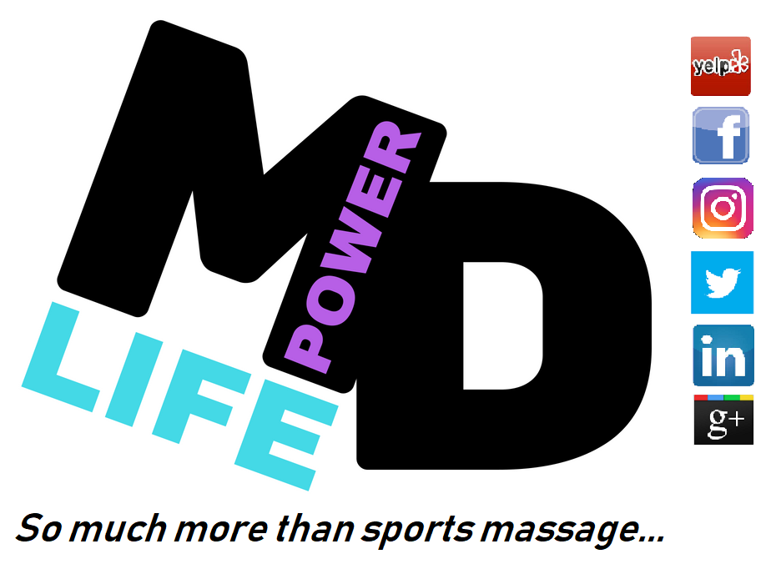 | Massage Services  Sports Massage  Cupping Massage  Medical Thai Massage  Therapeutic Massage  Full Body Massage  Reiki Healing  Cryo Service  Whole Body Cryotherapy  Integrative Services  $1 per Minute or Less  Infrared Himalayan Salt Sauna  FAR Infrared Carbon Sauna  Float/Deprivation Therapy  Infrared Sauna w/ Salt  90 rpm Fascia Roller  Halo Therapy  Oxygen Bar  Yoga Classes  Restorative Yoga  Beginner's Yoga  Swakriya Yoga  Hatha Yoga  Yoga Nidra  Flow Yoga  Vinyasa  Private Yoga  Couples/Partners  Sports Team  Family  1-on-1  Yoga Based Classes  Fitness/Cross Training  Restoration  Hard Core  Assessments  Functional Movement  Acute/Chronic Injury  Baseball Pitch  Gait Analysis  Softball Pitch  Chronic Pain  Golf Swing  Additional Services  Visualization Training  Nutritional Coaching  Community Services  Complimentary Workshops
I know it is 2018 but we must go back a little bit in time! 2014 was a busy year!
- Mirkin recanted and RICE was killed as an acute injury protocol; THANK GOODNESS!
- The American Medical Society for Sports Medicine (AMSSM) finally, and quite over due if you ask us, wrote a comprehensive paper on Overuse Injuries and Burnout in Youth Sports!
Yes, it was a year of vindication for us! Sadly, the 2017-2018 school year has been a very said year for our Loudoun High School Athletes. We saw almost double the number of preventable injuries than in previous years. Every injury was due to overtraining, improper warm up/no warm up, or lack of joint mobility and flexibility. Once they were injured many were told to rest, ice, and take ibuprofen, which caused even more pain, longer healing times and of course reaggravation as soon as they went back.
It is our hope to offer this information to prevent all of that!
This is a document written so simply that young athletes can understand it BUT is meant to inform and update Athletic Directors, Athletic Trainers, coaches, parents, and PE teachers so they can better understand, teach, and help prepare their athletes for activity as well as respond to acute injury more efficiently. We understand that most coaches were simply players and do what was taught to them, but information is more bountiful as time passes and we need to disseminate that to keep our young athletes healthy!
We will address:
- define stretching and when and why to use it
- defining warm up and cool down to it can be better utilized
- supplement with yoga-based movement for joint mobility, flexibility, joint stabilization, local muscle endurance, and cardio endurance
- acute injury management with current scientific-based and clinical based evidence
- Using PEAT & MEAT (Protect Exercise Analgesic Treatment and Movement Exercise Analgesic Treatment)
- current FDA warnings about NSAIDS – updated again in 2/2018
- the role of whole body cryotherapy for acute strains and sprains
- the role of Ktape for immobilization vs boot/brace
- reducing overuse from overtraining
- reducing burnout from overtraining
- structured time off versus rest
- how much scheduled time off is necessary each year to reduce injury – recommendations from AMSSM
- developing a maintenance/recovery protocol as part of a practice 1x a week
- preventable injuries and conditions
- Real Fitness - the making of an athlete
- how to tie your shoes – yes this matters
- walk-to-run before season begins
With more than 100 years of combined experience with playing sports, coaching, yoga teaching, sports therapy, and staying updated constantly with scientific-based and clinical-based practices, we offer the following information to reduce preventable injuries. Keep in mind most preventable injuries are due to no/poor quality/incorrect warm up, incorrect load bearing, no/incorrect cool down, and poor maintenance/cross training.
Nothing in this document is meant to be medical advise but rather clinical evidence that we have seen that lead to best practices.
From the MpowerD Team!
Owner
Holly Patterson
Lead Therapist, CMT, 200RYT, Acute and Chronic Pain Assessment
ABMP Insured Certified ACMT #808695
NCTMB #600630-10
Virginia Board of Nursing License #0019009767

Defining Stretching:
Type of Stretch | Definition
Warm Up | Dynamic: always using sports-specific movement to warm up. Make sure all joints needed for the activity are taken past the ROM needed for the activity and if this is done correctly there will be an increase in heart rate.
Cool Down | PNF THEN STATIC (IN THIS ORDER): always using sports-specific positions to cool down
Maintenance | DYNAMIC, PNF, THEN STATIC (IN THIS ORDER): always using sports-specific movement dynamically and once warmed up then use PNF and lastly static
Dynamic | utilizes momentum from form, static-active stretching strength and the momentum from static-active stretching strength, in an effort to propel the muscle into an extended range of motion not exceeding one's static-passive stretching ability. SIMPLY PUT: YOU MOVE CONSTANTLY IN WAYS THAT MIMIC YOUR SPORT
PNF (proprioceptive neuromuscular facilitation) | enhances both active and passive range of motion with the ultimate goal being to optimize motor performance and rehabilitation (counter for 7 seconds then push through further and repeat 3 rounds), it can negatively effect power and strength
Static Stretching | the body is at rest, muscles stretched to the first feeling of discomfort, held from 30 seconds up to 2 minutes, once the feeling of stretch passes, repeat
Ballistic | forces the limb into an extended range of motion when the muscle has not relaxed enough to enter it safely, involves fast "bouncing" movements where a double bounce is performed at the end range of movement CONSIDERED DANGEROUS for all athletes who are not gymnasts, dancers, and contortionists
Warning | ***BALLISTIC SHOULD ONLY BE USED AT THE END OF WARM UP IN SPORTS WHERE MOVEMENT PAST THE NORMAL ROM IS NEEDED, IT IS NOT AN EVENT THAT IS BEING TIMED, AND EVEN THEN UNDER VERY COMPETENT SUPERVISION*** GYMNASTICS, DANCE, CONTORTION
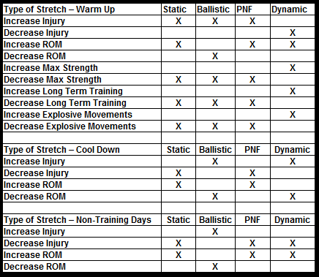
Yoga Based Movement for Athletes
I created a yoga-based movement class for general fitness and cross training for our athletes. We call it The Fitness/Cross Training Class, and it can help everyone! Whether you are trying to get fit, stay fit or cross train for your sport or other activities; this class has it all! Using yoga poses we create dynamic and static challenging series of movement that increase:
- joint stability
- range of motion in the joints
- flexibility
- strength
- power
- muscle endurance and tone
- cardiac endurance
- balance
- body awareness
- correct posture
- over all coordination
​Additional benefits to athletes are linear/lateral speed acceleration/deceleration​ and coordination!
There are innumerable benefits to a regular yoga practice.
- pain relief
- encourages self-care
- harmonious functioning of the body
  - adrenal function
  - cardio and circulatory health
  - respiration
  - blood pressure stability
  - easeful digestion
  - less risk for migraines
  - lymphatic system
  - immune system boost
  - spinal health

Acute Injury Management
We cannot possibly cover everything but please do not guess! Get professional help!
If someone can get in to see us for a sprain or strain within the first 24 hours and the athlete does NOT use ice and does NOT use NSAIDS, we have a track record of having them safely back in 3-5 days with a strain and 5-11 with a sprain!
**Please for the love of athletes STOP icing your athletes and telling them to take NSAIDS (Ibuprofen or Alleve). RICE was born of guessing NOT science! RICE is a mnemonic for four elements of treatment for soft tissue injuries – an acronym for Rest, Ice, Compression and Elevation. The mnemonic was introduced by Gabe Mirkin in Sportsmedicine Book (ISBN 978-0316574365) in 1978. However, he has since recanted his support for the regimen in 2014. So, why are people still using it? WE HAVE NO IDEA!
Please go to our website to read further articles. There are two exceptions to ice. One is a true muscle injury, when someone cannot get treatment the same day, the muscles can be iced 5M, off 5M, and then warm compress 5M, gentle stretching 5M, then repeat every hour (please keep in mind this usually takes a mature and intelligent athlete or knowledgeable coach to discern this). The other exception is IF there is someone who already has shin splints they can ice the fibula for pain reduction but should not have it on the musce
IMPORTANT:
Myths die hard; we all know that. Here are some myths debunked and further explanations as to why we choose PEAT or MEAT and why we hope you NEVER use RICE, NSAIDS, or get Cortisone shots for strains of tendons or sprains of ligaments.
PEAT
P: Protect. This could be from restricted movement (think kinesio tape) to short periods of immobilization with passive movement.
E: Exercise. Pain free, well assigned exercise helps to maintain an overall fitness base. Exercise promotes blood circulation and generally makes us feel better. Example are specific exercise for your injury and continuing with upper body strengthening after an ankle sprain.
A: Analgesic. Zim's Patches and Extra Strength Tiger Balm.
T: Treatment. It is advised that you seek treatment from a professional immediately as they can advise on the correct form of treatment.
MEAT
M: Movement. This should be controlled and within the limits of pain. It has been shown to promote blood flow to the affected area. It also helps to stimulate correct scar tissue formation.
E: Exercise. Pain free, well assigned exercise helps to maintain an overall fitness base. Exercise promotes blood circulation and generally makes us feel better. Example are specific exercise for your injury and continuing with upper body strengthening after an ankle sprain.
A: Analgesic. Zim's Patches and Extra Strength Tiger Balm.
T: Treatment. It is advised that you seek treatment from a professional immediately as they can advise on the correct form of treatment.
CORTISONE:
I have been preaching this for so long! I have been doing my best to promote natural healing but so many people want that "immediate relief." They do not understand that a little bit of guidance, soft tissue work, cupping, corrective movement, strengthening, and kinesio tape can go very far and actually HEAL them. Until orthos move away from fear of liability, which has them choosing immobility, ibuprofen, and cortisone for almost every strain and sprain and inflammatory response in the body, we will never see healing the way it can truly happen! I am so saddened how many people suffer needlessly with lingering pain that becomes chronic as well as further damage done to a tendon or ligament because it was covered up by cortisone. PLEASE, PLEASE, PLEASE DO NOT ALLOW ANY DOCTOR TO GIVE YOU A CORTISONE SHOT FOR STRAINS AND SPRAINS! Read on our website for an in-depth explanation about what really happens when cortisone is put in the body!
LACTIC ACID:
People think Lactic Acid is horrible, it was even stated as such in texts books 40 years ago. According to earlier beliefs, this build-up of lactic acid was a waste product that caused fatigue, burning muscles and could only be cleared during rest and recovery. Now we know that most of the lactic acid produced is used to produce immediate energy for your muscles and also plays an important part in generating additional glycogen to be used for energy. Another big myth is that massage can remove lactic acid. Massage CANNOT remove lactic acid. However receiving a massage within 2 hours of a vigorous workout has been shown to reduce inflammation.
IMMOBILIZATION:
Another myth is to stop moving. You're hurt! Wear a brace, boot, etc. It is not always true. Immobilization is NOT your friend for low grade strains and sprains. This is where we use PEAT and MEAT. Come see us ASAP so we can resolve it fast!
NSAIDS:
Take an NSAID as soon as you hurt? Not true! Using NSAIDS can slow healing. The doses are often wrong and have their own implications as well (see FDA warning below)! Please do not ever give a child Ibuprofen or Alleve. If pain control is absolutely necessary Tylenol can take the edge off and will not interfere with the healing cycle.
The FDA is (updated 2/2018):
The U.S. Food and Drug Administration (FDA) is strengthening an existing label warning that non-aspirin nonsteroidal anti-inflammatory drugs (NSAIDs) increase the chance of a heart attack or stroke. Based on our comprehensive review of new safety information, we are requiring updates to the drug labels of all prescription NSAIDs.
As is the case with current prescription NSAID labels, the Drug Facts labels of over-the-counter (OTC) non-aspirin NSAIDs already contain information on heart attack and stroke risk. We will also request updates to the OTC non-aspirin NSAID Drug Facts labels.
Patients taking NSAIDs should seek medical attention immediately if they experience symptoms such as chest pain, shortness of breath or trouble breathing, weakness in one part or side of their body, or slurred speech.
NSAIDs are widely used to treat pain and fever from many different long- and short-term medical conditions such as arthritis, menstrual cramps, headaches, colds, and the flu. NSAIDs are available by prescription and OTC. Examples of NSAIDs include ibuprofen, naproxen, diclofenac, and celecoxib (see Table 1 for a list of NSAIDs).
The risk of heart attack and stroke with NSAIDs, either of which can lead to death, was first described in 2005 in the Boxed Warning and Warnings and Precautions sections of the prescription drug labels. Since then, we have reviewed a variety of new safety information on prescription and OTC NSAIDs, including observational studies,¹ a large combined analysis of clinical trials,² and other scientific publications.¹ These studies were also discussed at a joint meeting of the Arthritis Advisory Committee and Drug Safety and Risk Management Advisory Committee held on February 10-11, 2014.
Based on our review and the advisory committees’ recommendations, the prescription NSAID labels will be revised to reflect the following information:
- The risk of heart attack or stroke can occur as early as the first weeks of using an NSAID. The risk may increase with longer use of the NSAID.
- The risk appears greater at higher doses.
- It was previously thought that all NSAIDs may have a similar risk. Newer information makes it less clear that the risk for heart attack or stroke is similar for all NSAIDs; however, this newer information is not sufficient for us to determine that the risk of any particular NSAID is definitely higher or lower than that of any other particular NSAID.
- NSAIDs can increase the risk of heart attack or stroke in patients with or without heart disease or risk factors for heart disease. A large number of studies support this finding, with varying estimates of how much the risk is increased, depending on the drugs and the doses studied.
- In general, patients with heart disease or risk factors for it have a greater likelihood of heart attack or stroke following NSAID use than patients without these risk factors because they have a higher risk at baseline.
- Patients treated with NSAIDs following a first heart attack were more likely to die in the first year after the heart attack compared to patients who were not treated with NSAIDs after their first heart attack.
- There is an increased risk of heart failure with NSAID use.
We will request similar updates to the existing heart attack and stroke risk information in the Drug Facts labels of OTC non-aspirin NSAIDs.
In addition, the format and language contained throughout the labels of prescription NSAIDs will be updated to reflect the newest information available about the NSAID class.
Patients and health care professionals should remain alert for heart-related side effects the entire time that NSAIDs are being taken. We urge you to report side effects involving NSAIDs to the FDA MedWatch program, using the information in the “Contact FDA” box at the bottom of the page.
https://www.fda.gov/Drugs/DrugSafety/ucm451800.htm
Whole Body Cryotherapy
Our clinical evidence has been amazing for acute injury care, frozen shoulder, hip impingement, all arthritis, chronic pain, and reduction in EOMS. Unfortunately, there are not ay large-scale studies (primarily because of funding issues) on acute care and whole body cryotherapy but there are studies that show very positive results in reports of decrease of EOMS, increased joint mobility, increased flexibility, and even showing significant results in frozen shoulder cases. Most of our high school athletes come in for cryo after a very hard training session/back to back playing days and the elite athletes cryo on a regular basis for better maintenance.
Kinesio Tape
Being able to use advanced kinesio taping methods for acute injury care makes a world of difference. We can use it in combination with Advanced Manual Techniques (Neurovascular and Neurolymphatic work) to help with neurological responses, or by slightly limiting ROM, and even speed up the inflammation cycle.

Preventing Injuries/Syndromes in Youth Sports
Over Use & Burnout in Youth Sports:
Higher training volumes have consistently been shown to increase the risk of overuse injury in multiple sports. Limiting weekly and yearly participation time, limits on sport-specific repetitive movements and scheduled rest periods are recommended. Such modifications need to be individualized based on the sport and the athlete's age, growth rate, readiness and injury history. Careful monitoring of training workload during the adolescent growth spurt is recommended, as injury risk seems to be greater during this phase. Preseason conditioning programs, proper cross training, and restorative programs can greatly reduce injury rates in young athletes.

Burnout is part of a spectrum of conditions that includes overreaching and overtraining. It has been defined to occur as a result of chronic stress that causes a young athlete to cease participation in a previously enjoyable activity. Sport specialization may be a factor. Data suggest that athletes who had early specialized training withdrew from their sport either due to injury or burnout from the sport. However, not all young athletes who drop out of sports are burned out. Most youth who discontinue a sport do so as a result of time conflicts and interest in other activities. Some may reenter the same sport or participate in a different sport in the future. In children there appears to be more of a psychological component related to burnout and attrition with adult supervised activities. To reduce the likelihood of burnout, an emphasis should be placed on skill development more than competition.
Structured time off to reduce injuries and regular recovery during season in practice or in place of a practice:
Bottom line is no sport should be all year! Athletes need breaks and should have structured recovery programs (yoga-based movement and cross training is amazing) meant to enhance the movement of the specific sport they are taking a break from. One study evaluating the relationships between seasonal patterns of athletic participation and overuse injury demonstrated a 42% increase in self-reported overuse injuries in high school athletes who participated all year versus 3 or less seasons per year! However, coaches who have implemented yoga as a weekly part of practice can attest to the benefits! We go to schools in Loudoun to hold classes during regularly scheduled practices. We bring mats, blocks, and yoga straps!
Shin Splints (Medial tibial stress syndrome):
This refers to pain along the shin bone (tibia). The pain will initially occur only with activity but can worsen to cause pain even with walking and at rest. Shin splints occur because of inflammation of the muscles and outer part of the shin bone called the periosteum. They tend to occur in athletes that participate in a lot of running as part of their sport.
Causes:
-Running increases too quickly
-Flat feet
-Very arched feet
-Worn out footwear
Prevention:
-Walk-to-Run program should be instituted before each season begins (in this document)
-Tying shoes correctly(in this document)
-Warming up with dynamic stretches
-Cooling down with Static Stretches
-Cross Training with no and low impact
Treatment:
-Rest is key
-Believe it or not a bag of frozen vegetables can be applied for 5M intervals, it's the bone!
-Correctly stretching lower legs
-New shoes
-Slow return to full activity

Osgood Schlatter:
Osgood Schlatter disease is an inflammation of the bone, cartilage, and/or tendon at the top of the tibia, where the tendon from the patella attaches. It affects youth experiencing growth spurts. Youth who play sports in which they regularly run and jump are most at risk.
Causes:
-Growth spurts
-Overuse from running and jumping
-Running increases too quickly
-No or improper warm up
-No or improper cool down
Prevention:
-Walk-to-Run program should be instituted before each season begins during growth spurts (in this document)
-Warming up with dynamic stretches
-Cooling down with Static Stretches
-Cross Training with no and low impact
Treatment:
-Rest is key
-Believe it or not a bag of frozen vegetables can be applied for 5M intervals, it's the bone! Don't ever eat the vegetables after using it for this.
-Correctly stretching lower legs
-New shoes
-Slow return to full activity

Sever's Disease:
Sever's disease, also called calcaneal apophysitis, is a painful bone disorder that results from inflammation (swelling) of the growth plate in the heel. A growth plate, also called an epiphyseal plate, is an area at the end of a developing bone where cartilage cells change over time into bone cells. As this occurs, the growth plates expand and unite, which is how bones grow.
Sever's disease is a common cause of heel pain in growing kids, especially those who are physically active. It usually occurs during the growth spurt of adolescence, the approximately 2-year period in early puberty when kids grow most rapidly. This growth spurt can begin any time between the ages of 8 and 13 for girls and 10 and 15 for boys. Sever's disease rarely occurs in older teens because the back of the heel usually finishes growing by the age of 15, when the growth plate hardens and the growing bones fuse together into mature bone.

Causes:
-Growth spurts
-Overuse from running and jumping, hard surface sports, and gymnastics
-Running increases too quickly
-No or improper warm up
-No or improper cool down
-Standing too long
-Pronated feet
-Obesity
-Flat or high arches
Prevention:
-Walk-to-Run program should be instituted before each season begins during growth spurts (in this document)
-Warming up with dynamic stretches
-Cooling down with Static Stretches
-Cross Training with no and low impact
Treatment:
-Rest is key
-Believe it or not a bag of frozen vegetables can be applied for 5M intervals, it's the bone! Don't ever eat the vegetables after using it for this.
-Correctly stretching lower legs
-Correctly strengthening lower legs
-New shoes with inserts for cushion
-Slow return to full activity
-Recurrence is common so PLEASE follow prevention

Fitness
Some of the most frustrating things for us to see is an athlete who says they are weight lifting with their coach not a professional (often times they say it is alone and no adults are in the weight room) and they cannot even perform a body weight bearing squat correctly. Another one is an athlete who is benching heavy and cannot hold themselves in a simple plank. We have even seen young athletes sent to work on speed and agility training who have no control over their bodies. Lastly, we hear about trainers that clubs or teams use that for some reason are replicating sports movement instead of cross training them properly.
A brief overview is simple:
1st phase (9 years old and up): should start with building strength by working on body weight bearing with perfect form, resistance training with perfect form, balance, and flexibility
-yoga based movement
-functional movement
-restorative movement
-even dance classes like hip hop/ballet can help
2nd phase: once they have demonstrated mastery over their body weight, understanding warm up, cool down, and are still maintaining flexibility, and balance, they can start free weights and light weight lifting with a professional
-this should be learned either 1 on 1 or in a small group where there can have a watchful eye
3rd phase: added last they can begin to lift heavier with a professional
-this should be learned either 1 on 1 or in a small group where there have be a watchful eye

- Strength- the extent to which muscles can exert force by contracting against resistance
(holding or restraining an object or person)
- Power- the ability to exert maximum muscular contraction instantly in an explosive burst of movements. The two components of power are strength and speed.
(jumping or a sprint start)
- Agility- the ability to perform a series of explosive power movements in rapid succession in opposing directions
(ZigZag running or cutting movements)
- Balance- the ability to control the body's position, either stationary, handstand, or while moving, a gymnastics stunt
- Linear/Lateral Speed & Acceleration/Deceleration- the ability to control the body's movement quickly
- Flexibility- the ability to achieve an extended range of motion without being impeded by excess tissue, fat or muscle
(executing a leg split)
- Local Muscle Endurance- a single muscle's ability to perform sustained work
(rowing or cycling)
- Cardiovascular Endurance- the heart's ability to deliver blood to working muscles and their ability to use it
(running long distances)
- Strength Endurance- a muscle's ability to perform a maximum contraction time after time
(continuous explosive rebounding through an entire basketball game)
- Co-ordination- the ability to integrate the above listed components so that effective movements are achieved.

Tie your shoes correctly!
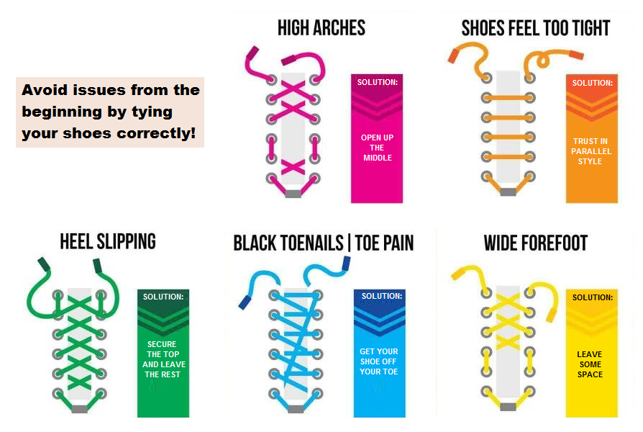

Walk to Run Program
Ideal for brand-new runners, or those returning to the sport from injury or a long layoff, a run/walk program guides the athlete to a safe transition from non-running to running, or allows him or her to return to running successfully.
Before beginning this run/walk training plan, note the following:
- Consult your doctor before beginning a new exercise routine—he or she should place you in the stage of this plan that's the most appropriate for you.
- This is a dynamic process and will need adjustment. If you are returning from a stress fracture or repetitive load injury, we suggest you have a gait analysis (Joe) and shoe check (Holly) early in this process to prevent a recurrence.
- You can help your running form and prevent injury by doing a core program two to three times a week (Holly).

Rules of Progression
Each stage should last one week. You can progress the total time by increasing the interval. In stages 1 to 8, do not increase the interval by more than one.
If you have pain, skip a run (three days), and return to the previous stage. If you still have pain at that lower stage, please notify your doctor for repeat Xrays.

Interval Walk/Jog/Run Program
Stages 1-3
Warm up dynamically without weight bearing (Holly). Walk steady with a good arm swing and gait . The jog is very easy in order to work on your form. Complete the workouts no more than three times per week on an even, predictable surface. One day of rest in between each and MUST be followed with sitting on knees in feet flat and toes tucked positions and a deep squat.

Stage 1 (16 minutes)
3-minute walk/1-minute jog

Stage 2 (18 minutes)
2-minute walk/1-minute jog
Stage 3 (20 minutes)
2-minute walk/2-minute jog
Stages 4 to 8
Jog steady (no intensity still); the walk should be performed with proper form, including good arm swing. Complete the workouts should no more than four times per week.
Stage 4 (25 minutes)
4-minute jog /1-minute walk
Stage 5 (28 minutes)
6-minute jog/1-minute walk
Stage 6 (32 minutes)
7-minute jog/1-minute walk
Stage 7 (36 minutes)
8-minute jog/1-minute walk
Stage 8 (50m)
9-minute jog/1-minute walk

Stages 9 to 11
The run pace intensity can increase by adding strides—quicker-paced running for 50 to 100 meters. Remember to focus on good form. Terrain can vary. Run the strides at 75 to 85 percent of normal pace prior to injury, or if you're new to running, run the strides at a faster pace than you have been, but not an all-out effort. The walk is the same as above. You may want to do a shorter steady run without breaks on other training days.
Stage 9 (56 minutes)
7-minute run with 4 strides/45-second walk
Stage 10 (63 minutes)
8-minute run with 5 strides/45-second walk
Stage 11 (70 minutes)
9-minute run with 6 strides/45-second walk

Stages 12 to 13
Build your interval times to match your desired event.
Example 1: I plan on running 7:30 per mile pace for a marathon, and I want to walk to fuel every 2 miles. That means I should train to achieve a 15-minute run/1-minute walk goal.
Example 2: I plan on running 10:00 per mile pace for a half marathon, and walk 30 seconds through the aid stations. This would give 10-minute run/30-second walk.

